# Data Centric RAD

## Lab 8 JSF Introduction

### Setting up a JSF Project

* Open Eclipse Java EE IDE for Web Developers.
* Select *File/New/Other/Web/Dynamic Web Project*.
* Enter a project name and select the Target runtime as shown:

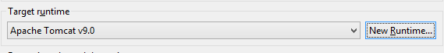

* + If there are no options, press *New Runtime*
  + Click on Apache Tomcat v9.0 and press *Next*
  + Browse to the Apache Tomcat installation directory and press *Finish*

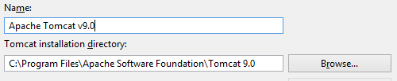

* Press *Next* until the *Web Module* screen appears, select the *Generate web.xml deployment descriptor* and press *Next*.

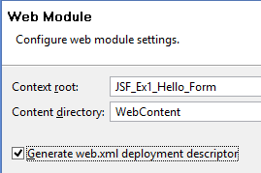

* Press *Finish* on the *JSF Capabilities* window.
* The Dynamic Web Application project has now been created.

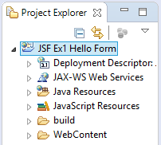

* Goto <http://repo1.maven.org/maven2/org/glassfish/javax.faces/2.2.9/> and download the following jar file [javax.faces-2.2.9.jar](http://repo1.maven.org/maven2/org/glassfish/javax.faces/2.2.9/javax.faces-2.2.9.jar) to the *WebContent\WEB-INF\lib* in the project.
* Download the MySQL driver from <https://dev.mysql.com/downloads/connector/j/>. Extract the jar file and place it in *WebContent\WEB-INF\lib* in the project.
* Select *Project/Properties/Project Facets*.
* Select *JavaServerFaces 2.2* and then click *Further configuration required…*

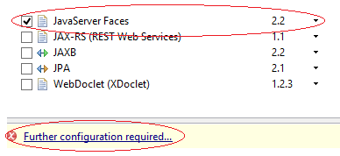

* The *Modify Faceted Project* window now opens. Change the *JSF Implementation Library Type* to *Disable Library Configuration* and press *OK*, then press *OK* on the *Properties* window.



* In Eclipse, right-click on the *WebContent* folder and select *New/HTML File*.
* Enter a file name ending in *.xhtml* e.g. *index.xhtml* and press *Next*.
* Delete any text in *index.xhtml* and replace with the following text:

<!DOCTYPE html>

<html xmlns=*"http://www.w3.org/1999/xhtml"*

xmlns:h=*"http://xmlns.jcp.org/jsf/html"*

xmlns:f=*"http://xmlns.jcp.org/jsf/core"*>

<h:head>

<title>JSF Hello World Application</title>

</h:head>

<h:body>

<h3>Hello World</h3>

</h:body>

</html>

* To run each exercise below, select the *index.xhtml* file and select *Run/Run As/Run on Server* in Eclipse.

### Part 1 JSF Student Details Form

* Write a JSF web application that allows a Student to enter the following details
  + First Name (The input field should say *First Name*)
  + Surname (The input field should say *Surname*)
  + Address (The input field should allow multiple lines)
  + Phone Number
  + Age
  + Sex (Male and Female should be radio buttons)

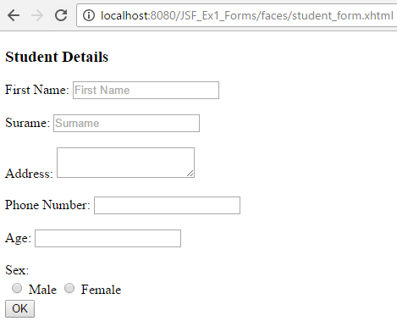

When the user enters his/her details and presses *OK*, for example as follows:

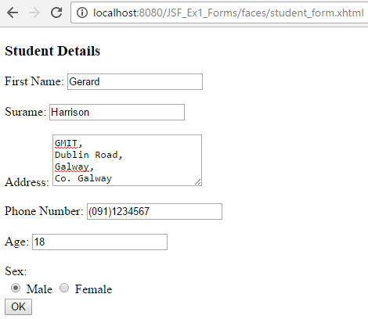

Another web page should display his/her details as follows:

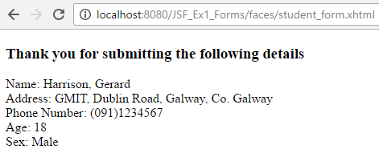

### Part 2 JSF Student Details Form

* Update Part 1 to include a cancel button on the student registration form:

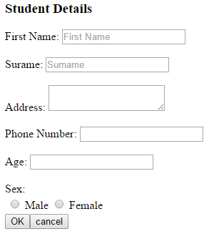

If the cancel button is pressed a new web page should display a message and a link to get back to the student registration form:

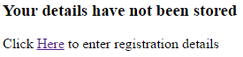

### Part 3 JSF Student Details Form

* Update Part 2 to include a drop down list of the following colleges on the student registration form:
  + GMIT
  + NUIG
  + UCD
  + UL

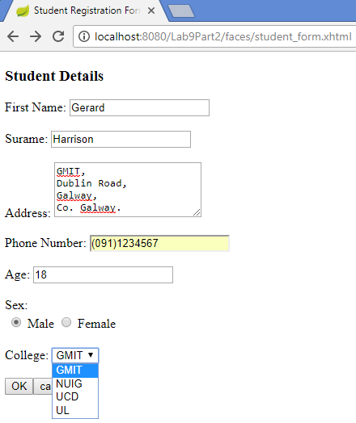

* When the user enters his/her details and presses *OK*, the following page should be displayed:

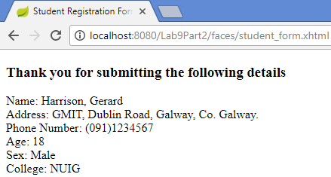

### Part 4 JSF Employee Details Form

* Write a JSF web application with two h:inputText elements.
* The first one displays the employee’s name and can be hardcoded in the view.
* The second allows the user to enter the employee’s title. Before anything is entered “Enter Title” should appear in the h:inputText.
* The Employee name should not be editable.

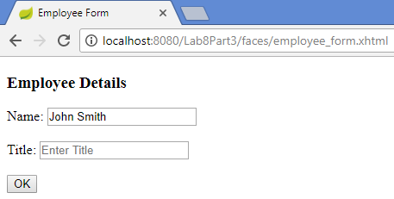

* Once the user has entered a title as shown:

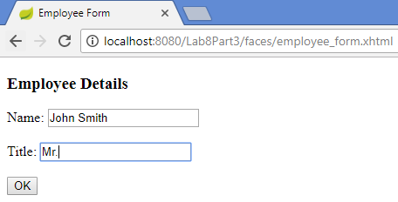

he/she should be brought to another page which displays the title just entered:

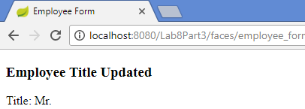

NOTE: To make an inputText uneditable add the following property to the inputText:

readonly="#{facesContext.currentPhaseId.ordinal eq 6}"